**Clarification required in Shopping Cart**

**Add to Cart**

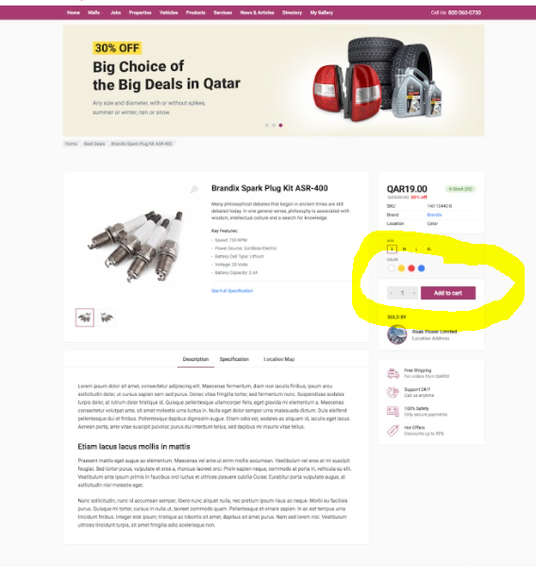

* Here we will be using below apis to add into cart
* <http://175.41.176.135:3000/apidoc/#api-Shopping_Cart-PostV1UsersUser_idCart>
* <http://175.41.176.135:3000/apidoc/#api-Shopping_Cart-PostV1UsersUser_idCartService>

**Shopping Cart**

* Here we need to display Products and services in two different tabs, without any checkboxes.
* <http://175.41.176.135:3000/apidoc/#api-Shopping_Cart-GetV1UsersUser_idCart>
* <http://175.41.176.135:3000/apidoc/#api-Shopping_Cart-GetV1UsersUser_idCartService>
* Quantity part is there, do we have separate API for product and services to update based on the quantity(Currently only Product cart update is there)
* <http://175.41.176.135:3000/apidoc/#api-Shopping_Cart-PutV1UsersUser_idCart>
* In Displaying the Cart Total, From the API, Do we get the shipping charge?
* Products and services, both together will do the checkout?

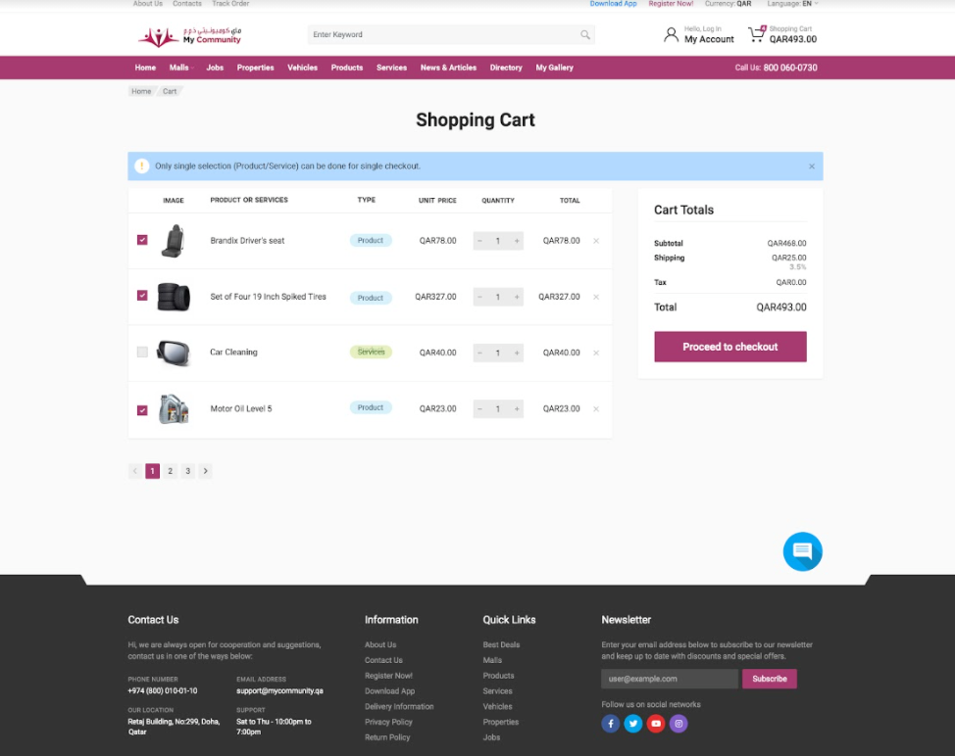

* Here we will be displaying the products added in the cart(both products and services will be listing), So here below two api will be using
* <http://175.41.176.135:3000/apidoc/#api-Shopping_Cart-GetV1UsersUser_idCart>
* <http://175.41.176.135:3000/apidoc/#api-Shopping_Cart-GetV1UsersUser_idCartService>
* What happens when we click Place order button?

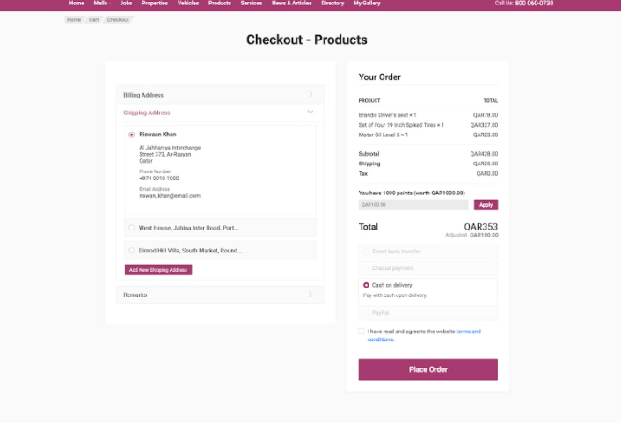

**Best Deal**

* Clarification Required
* We are not creating any best deals(Product/Services) from our web

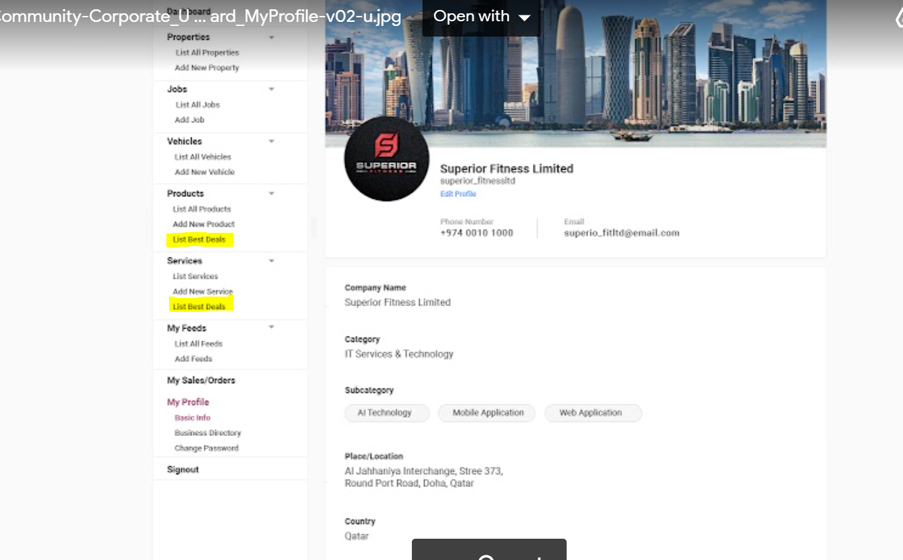

* Which API are we using to list the best deals in Products and Services of dashboard?

**Redeem Points**

* As discussed in last meeting, we will be showing the redeem points in below screen**.**
* **How we get the redeem points?**

